**Experimental procedure**Mechanochemical synthesis of CsCu2X3 powder

# Motivation

We have successfully synthesised a high-quality CsCu2I3 powder with mechanochemical synthesis. The powder depicts a large Stokes shift and fast-nanosecond gamma ray decay. To increase the contribution of direct recombination as we have done previously with Cs3Cu2I5, structural changes by Br doping. Herein, we aim to

# Apparatus preparation

Please prepare/ borrow the following laboratory apparatus from the CSL lab:

* Analytical balance
* Ultrasonic bath
* Ethanol 96%
* Parafilm tape
* Glass powder tubes (5 mL)

From the private cabinet, prepare the following laboratory apparatus:

* Spatula (matched to the number of precursors)
* Mortar and pestle

# Cleaning procedure

To ensure sample purity, you must take the following precautions:

1. Always wear gloves, mask, hair clip, lab coats, and closed-toe shoes. Do not eat and drink during synthesis at any excuse!
2. Before starting the synthesis:
   1. Clean your hands and face. Tie up your hair if applicable. Wear the appropriate clothing.
   2. Clean the spatula, mortar-pestle, beakers, and glass powder tube with 96% ethanol. Then, put the apparatus in the ultrasonic bath for 15 minutes. For the bath, use water from the filtration system available. Use facial tissues exclusively to dry the bathed apparatus. Clean and wipe them with 96% ethanol again afterwards. To keep things neat, use a basket layered with facial tissues. Change the facial tissues every once it is used.
3. During synthesis:
   1. Do not use the same spatula to obtain two different precursors. If your hands are sweaty, change the gloves often.
4. After finishing the synthesis:
   1. Clean and wipe the apparatus with ethanol. Wrap them with facial tissues and store them inside a designated cabinet.
   2. Throw away your gloves and masks. Do not reuse them on the next day.

**Experimental**

We will use the mechanochemical synthesis procedure similar to previous works1, as illustrated in Figure 1a.

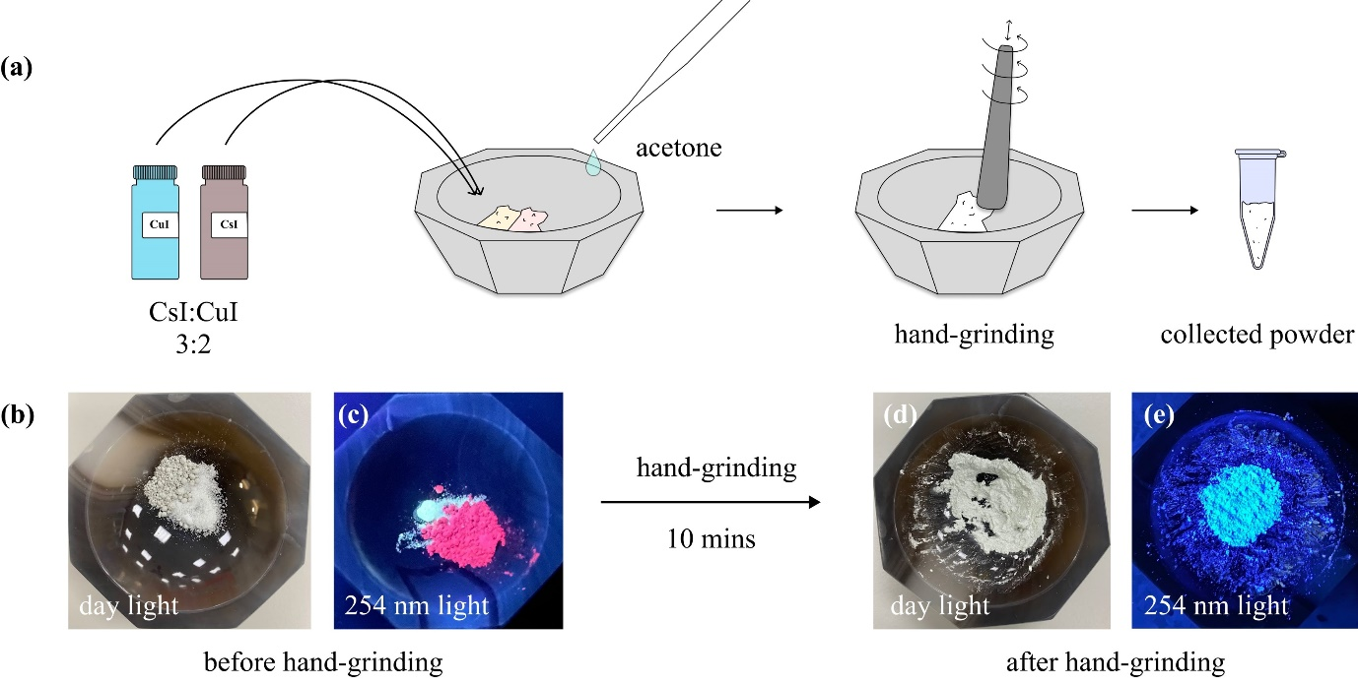

**Figure 1** (a) Mechanochemical synthesis steps of caesium copper iodide perovskite; photographs of precursor mixture under (b) daylight and (c) 254 nm UV light; photographs of the mechanosynthesised perovskite under (d) daylight and (e) 254 nm UV light.

***CsCu2X3.*** The initial and final product will have a white colour but should be yellow under 254 nm light (or near that wavelength).

**References**

(1) Grandhi, G. K.; Viswanath, N. S. M.; Cho, H. B.; Han, J. H.; Kim, S. M.; Choi, S.; Im, W. B. Mechanochemistry as a Green Route: Synthesis, Thermal Stability, and Postsynthetic Reversible Phase Transformation of Highly-Luminescent Cesium Copper Halides. *J. Phys. Chem. Lett.* **2020**, *11* (18), 7723–7729. https://doi.org/10.1021/acs.jpclett.0c02384.